STUDY METARIAL NO… 44
FOR D - I (GEOGRAPHY SUBSIDIARY)
PAPER -1 PHYSICAL GEOGRAPHY
ORIGIN OF OCEAN BASINS
BY
Dr. ALPNA JYOTI
LNM University
Marwari College Darbhanga
Darbhanga
Oceanography, the science of sea , is a subject of modern growth though its foundation can be tracked back to the earliest time. It is Concerned with the eluciadation of may intricate and complex problems of physical and biological nature and practical problem of sea, which form, so large a part of the environment of mankind.
The floors of the oceans are not plain as believed earlier. They are rugged and complex with world‘s longest mountain ranges, deepest trenches and largest plain. The development of the sonic depth recorder has made it possible to measure depth for mapping the ocean floor indirectly with help of sound waves. The data revel many complex and varied features, witch rival anything about relief feature on the land. Ocean basin is defined as that part of the sea floor deeper than 2000 meters . An oceanic basin may be anywhere on the Earth that is covered by seawater, but geologically ocean basins are large geologic basins that are below sea.
Major Division of Ocean Floor
Geologically, the ocean floor can be divided into four major division.--------
- Continental shelf
- Continental slope
- Continental rise
- The abyssal plain
Besides, these are many associated feature including ridge, hills, sea mounts, guyots, trenches, canyons, deeps and fractures zones. Numerous island arcs, atolls, coral reefs, submersed volcanoes and sea- scraps add to the variety of submarine features. As the trenches and ridge abound on the ocean floor, the ridge and basin topography is the characteristic of the ocean bottom. The great variety of relief is largely due to the interaction of tectonic, volcanic erosional and depositional process. At greater depths, tectonic and volcanic phenomena are more significant process. Older reference consider the oceanic basins to be complement to the continents, with erosion dominating the latter and the sediments, so derived ending up in the ocean basins. More modern source regard the ocean basins more as basaltic plains, than as sedimentary depositories, since, most sedimentation occurs on the continental shelves and not in the geological defined ocean basins.
Continental Shelf:----
The continental shelf is a gentle seaward sloping surface extending between the shoreline and the continental slope. It is, in fact, the belt of shallow water extending from the coasts towards the open sea or part of the continental area now covered by sea-water.
The width of the continental shelf varies greatly ranging from a few kilometre to more than 1000km. Along the eastern coast of the India such a wide self strip os noted . However, the average width is about 70km and mean slope is less than 1 degree. There are various types of shelves including coral reef shelf, Shelf with dendritic valleys and the shelf along young mt. ranges. Old beaches and morains can both be identified on the shelves. The shelves of the world are of great use to man. Maine food comes almost entirely from them. They provide the richest fishing grounds.
Continental Slope:----
At the edge of the continental shelf, the seaward slope becomes considerably steep, the angle of slope varying from 2 to 5 degreees. This steep slope, which decends to a depth of about 2000 fathoms from the mean sea level is known as Continental Slope.

There are 5 types of slope :
- Fairly steep with the surface dissected by canyon.
- Gentle slope with elongated hills and basins.
- Faulted slopes
- Slopes with terraces
- Slopes with seamounts
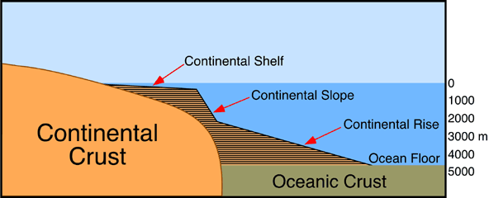

Continental Rise:----
Whese the continental slope ends, the gently sloping continental rise begins. The continental rise has an average slope of between 0.5 to 1 degree and its general relief is low. With the increasing depth the continental rise become virtually flat and it merges with the abyssal plain.
Abyssal plain :----
Beyond, the continental slope lie the deep sea plains known as the abyssal plain or abssal floors. They are the areas of deep ocean floor found at the depth of 3000 to 6000 metres. They occupy about 40% of the ocean, floor and are present in all major oceans and several seas of the world. They are uniquely flat with the gradient of less than 1:100. They are bounded by the hills on the seaward side. The abyssal plains are covered by sediments both of terrigenous and shallow water origins.

-------------- 0 -------------

